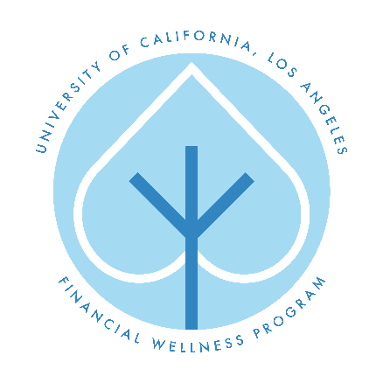
Student Loan Repayment and Financial Planning Checklist
As you begin to prepare to leave school, it is important to be informed about your student loan repayment processes and the options you have. To aid you in this journey, the Financial Wellness Program at UCLA created the following step by step checklist as a guide.
1. LOG ON to NSLDS.ed.gov [you will need your PIN and personal information to
log in].
2. REVIEW the types of loans you have.
3. KNOW the interest rates, loan amounts as well the terms and conditions of your loans.
4. IDENTIFY your loan servicers and their contact information.
5. GATHER all supporting documents (Master Promissory Notes-MPN etc…)
6. KEEP all personal information up to date with loan servicer
7. SIGN UP to manage your account online and to receive paperless email communications
8. SELECT a payment plan that best suits you by contacting your servicer
9. USE the Repayment Calculator at studentloans.gov to estimate repayment amounts
10. POSTPONE repayment on federal student loan via deferment, forbearance and other forms
of payment relief. Visit studentaid.gov
11. RESEARCH loan consolidation if you have multiple loans. Visit studentaid.gov
12. LEARN about loan discharge and forgiveness opportunities. Visit studentaid.gov
13. UNDERSTAND student loan interest deduction (IRS form 1098-E)
14. RESPOND to all billing statements, even if you think it may be an error. Most discrepancies
can be resolved quickly.
Website Resources:
UCLA Financial Wellness Page: www.financialwellness.ucla.edu
UCLA Financial Wellness Facebook Page: https://www.facebook.com/uclafinancialwellness
Federal Student Aid – US Department of Education: https://studentaid.ed.gov
National Student Loan Data System: https://www.nslds.ed.gov
STUDENT LOAN TERMINOLOGY
Loan Type Interest% Servicer/Resources
Direct Subsidized Loan | 4.29% | Federal Government/ StudentLoans.gov
Direct Unsubsidized Loan | 4.29%/6.21% | Federal Government/ StudentLoans.gov
Direct PLUS Loan | 7.21% | Federal Government/ StudentLoans.gov
Federal Perkins Loan | 5% | Contact your school’s financial aid office
Private/Alternative Loan | varies | Contact your lender or servicer
Repayment Type Description Tips
Income-Based Repayment (IBR) | -must show yearly proof of partial financial hardship  -your maximum monthly payments will be 15% of discretionary income (the difference between your adjusted gross income and 150 percent of the poverty guideline for your family size and state of residence)  *new borrowers it is 10%  -Your payments change as your income changes.  -Up to 25 years | -monthly payments will be lower than the standard plan.  -you'll pay more in loan interest over time  -If you have not repaid your loan in full after making 25 years of qualifying monthly payments, any outstanding balance on your loan will be forgiven.  -You may have to pay income tax on any amount that is forgiven.
Pay As You Earn | -You must show yearly proof of a partial financial hardship.  - Your maximum monthly payments will be 10% of discretionary income (the difference between your adjusted gross income and 150 percent of the poverty guideline for your family size and state of residence)  -Your payments change as your income changes.  -Up to 20 years | -must be a new borrower on or after Oct. 1, 2007  -must have received a disbursement of a Direct Loan on or after Oct. 1, 2011.  -monthly payments will be lower than payments under the 10-year standard plan.  -You'll pay more loan interest over time  -If you have not repaid your loan in full after you made the equivalent of 20 years monthly payments, any outstanding balance on your loan will be forgiven.  -You may have to pay income tax on any amount that is forgiven.
Income-Contingent Repayment (ICR) | -You must show yearly proof of a partial financial hardship.  -Payments calculated each year and based on your adjusted gross income, family size, and the total amount of your Direct Loans.  -Your payments change as your income changes.  -Up to 25 years | -You'll pay more loan interest over time  -If you do not repay your loan after making the equivalent of 25 years of qualifying monthly payments, the unpaid portion will be forgiven.  -You may have to pay income tax on the amount that is forgiven.
Standard Repayment | -Payments are a fixed amount of at least $50 per month.  -Up to 10 years  -If you do not select another repayment plan, this is the plan your servicer will automatically sign you up for | -saves you money on interest over time because your monthly payments may be slightly higher  -you’ll pay off your loan in the shortest time
Graduated Repayment | -Payments are lower at first and then increase, usually every two years.  -Up to 10 years | -you will end up paying more in interest than the standard plan
Extended Repayment | -Payments may be fixed or graduated.  -Up to 25 years | -your monthly payments will be lower than under the standard 10 year plan  -must have more than 30,000k in direct loan debt  -you’ll end up paying more in interest over time
What if I cannot make payments due to financial hardship?
Deferment | Period during which repayment of the principal and interest of your loan is temporarily delayed. Government will pay interest on all loans except unsubsidized and PLUS loans during this time. Must meet qualifications. studentaid.gov
Forbearance | In the case that you do not meet deferment qualifications, you may be able to stop making payments or reduce your monthly payment for up to 12 months for up to 3 years. Interest will continue to accrue on your loans. Must meet qualifications for either a mandatory or discretionary forbearance. studentaid.gov

